*Test : sales application.*

*Link for sales application. -*

* *Create a project in name without any space between the names.*

*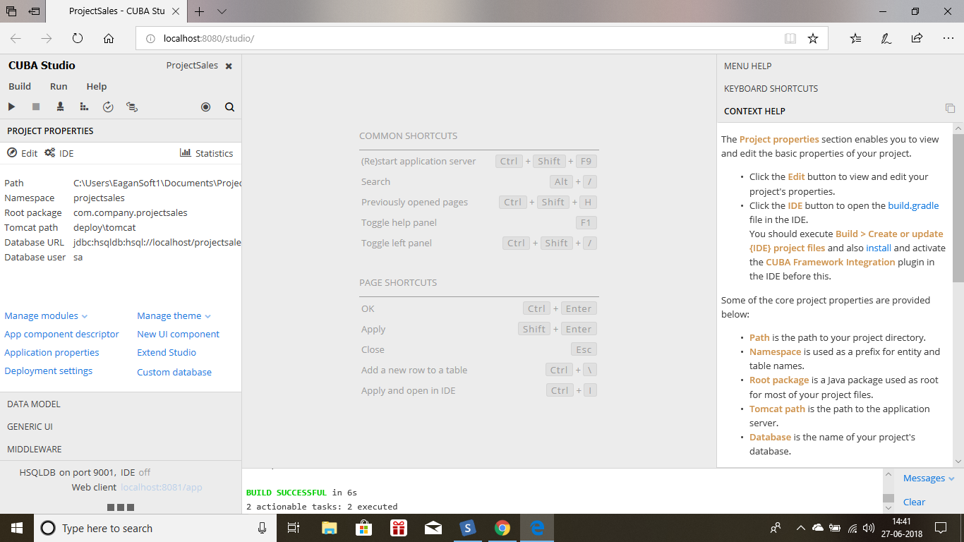*

* *First create database.*

*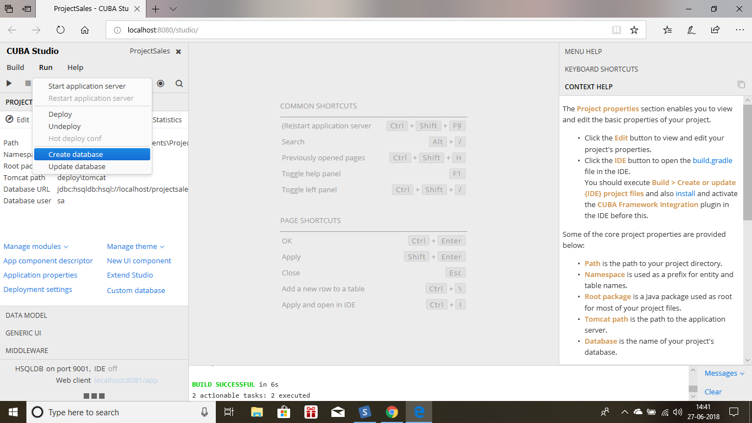*

**

* *Create model class customer and give its attributes as name and email and both are mandatory.*

*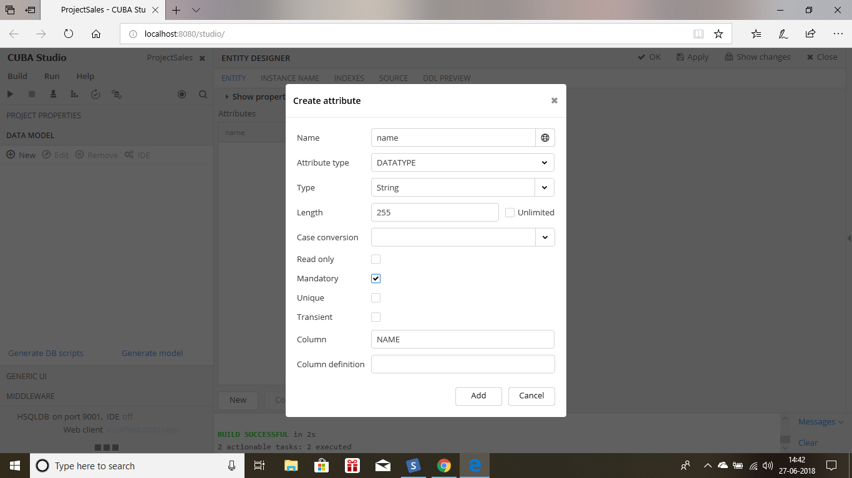*

*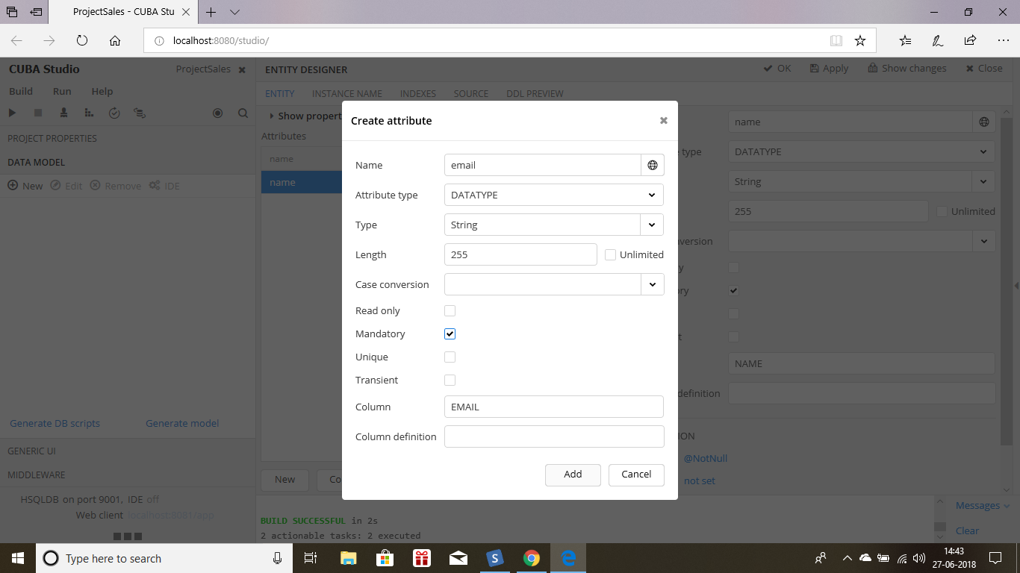*

* *Create instance name and give name.*

*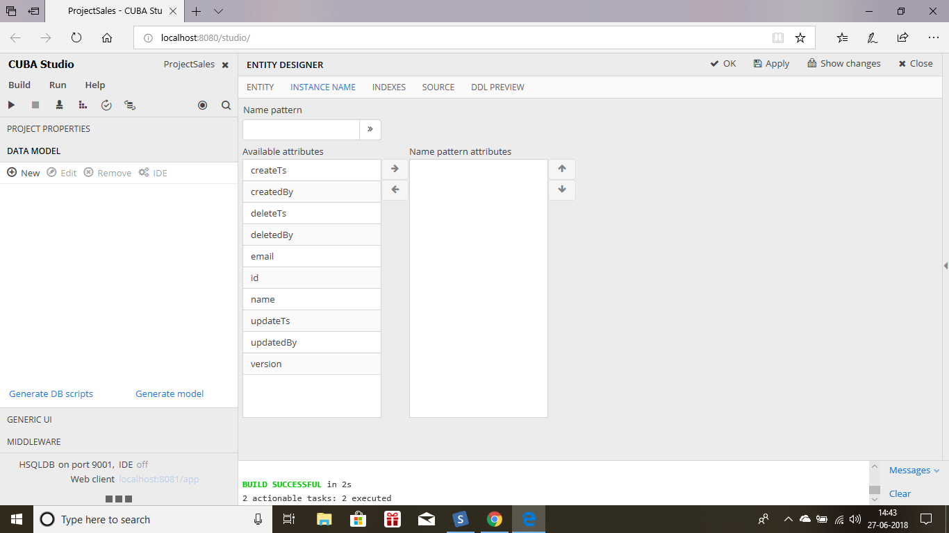*

*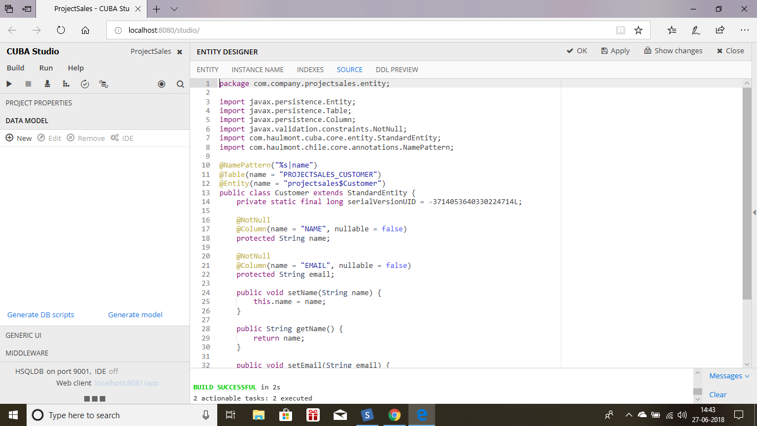*

* *Create db scripts for this customer model and then update or create the database.*

*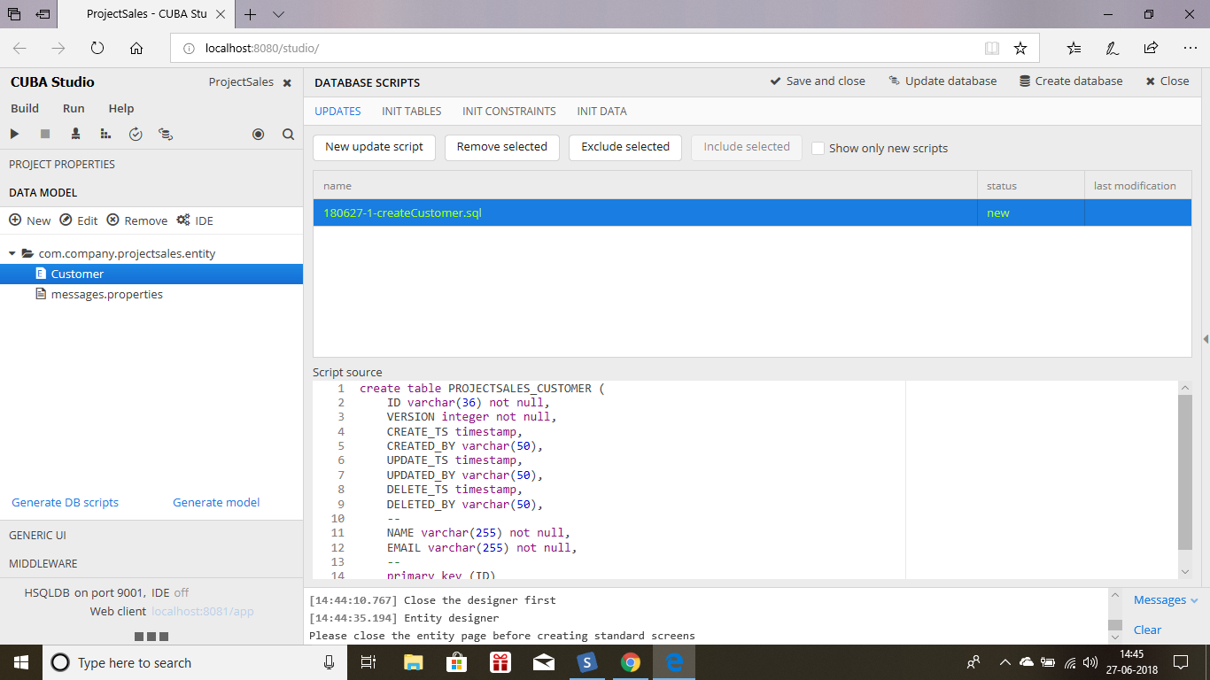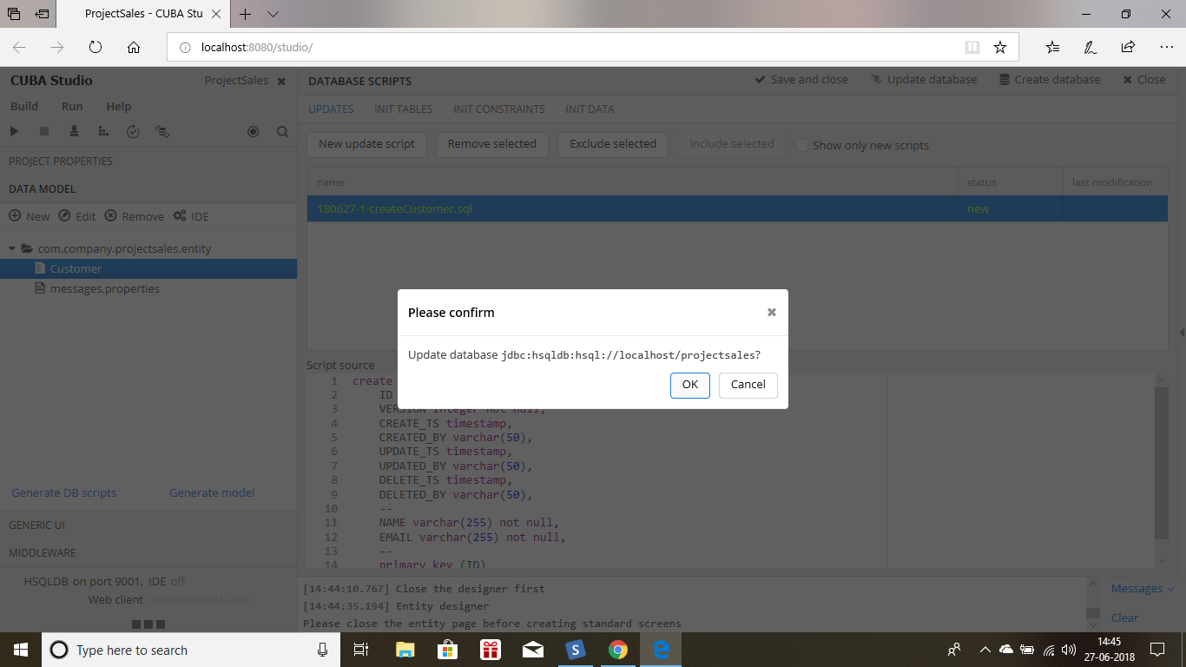*

* *Create generic UI screen for this customer.*

*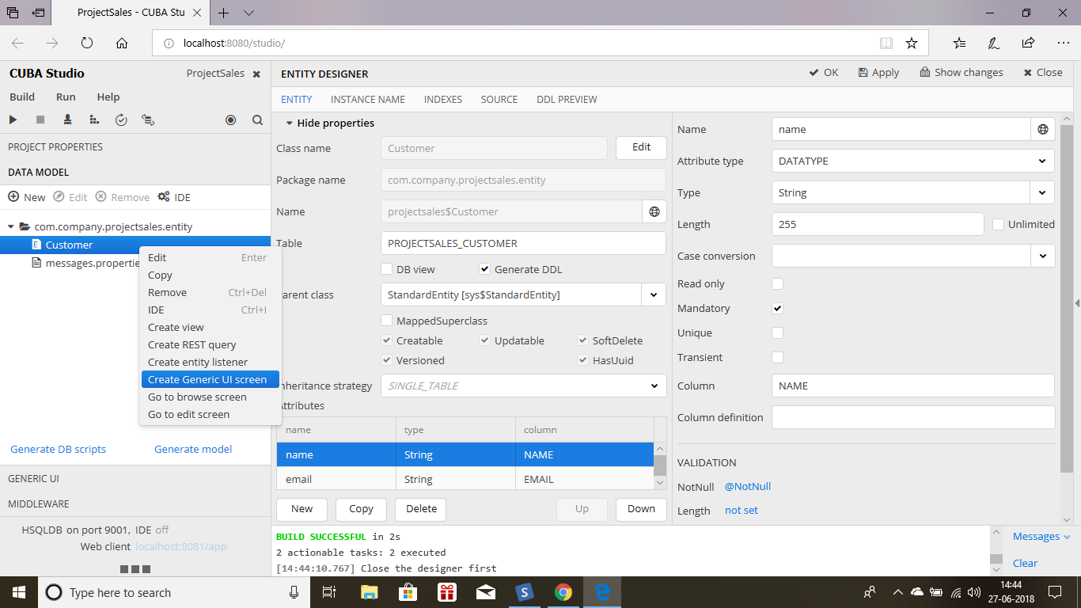*

*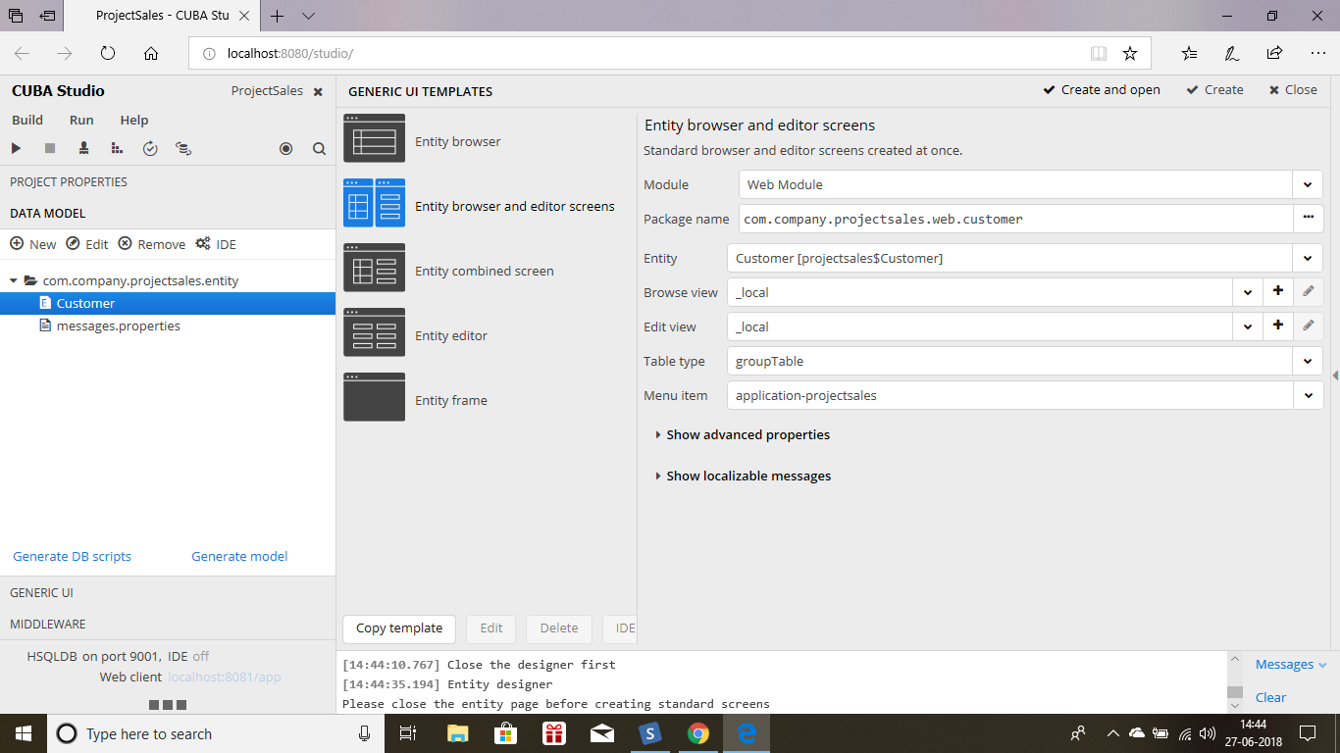*

* *Run the server and see whether you can enter name and email field properly.*

*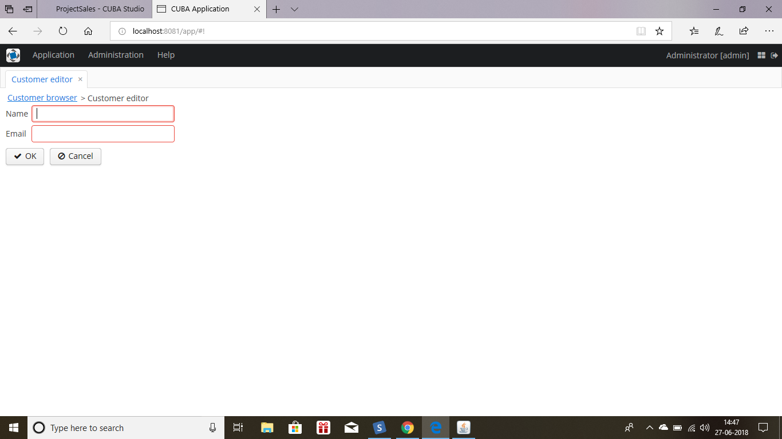*

*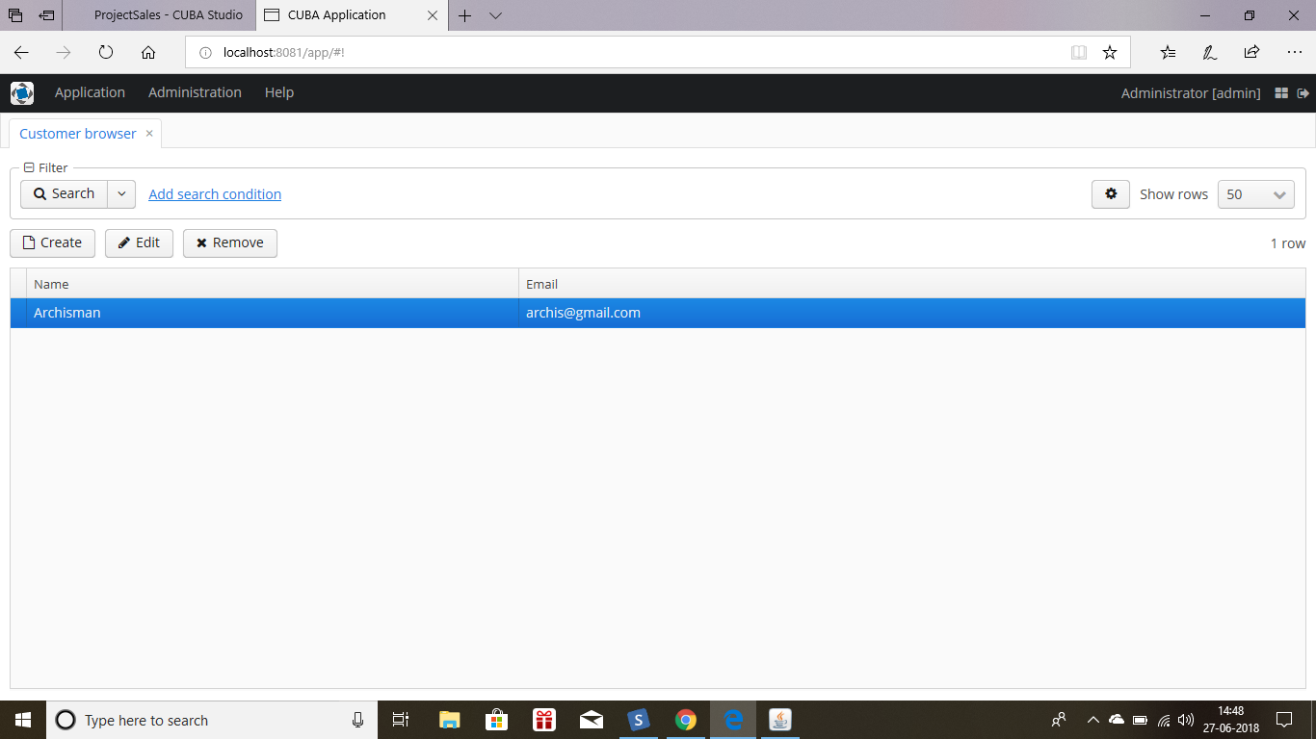*

* *Now create a model class called as Order. And this order will have one to many relationship with this customer.*

*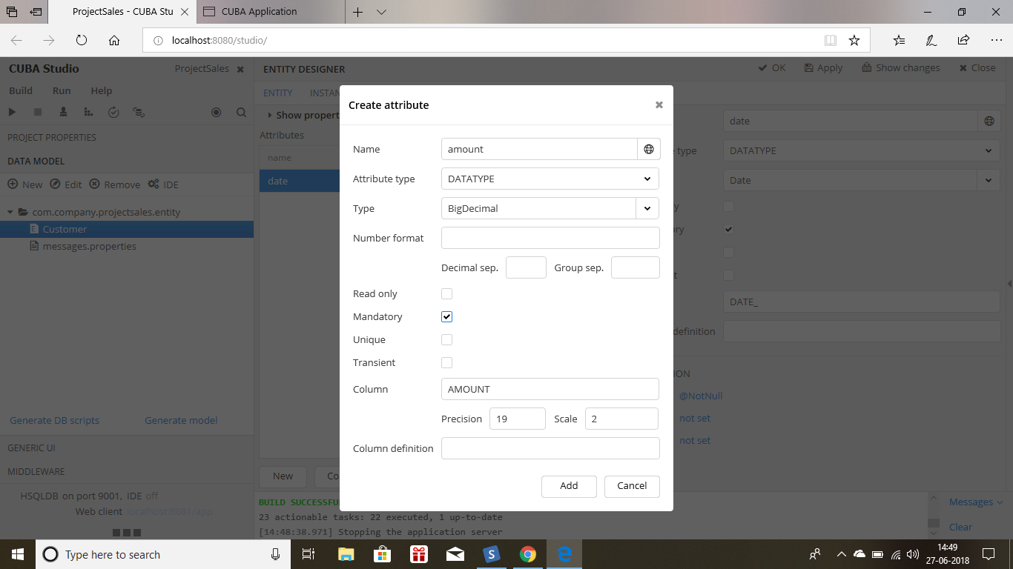*

*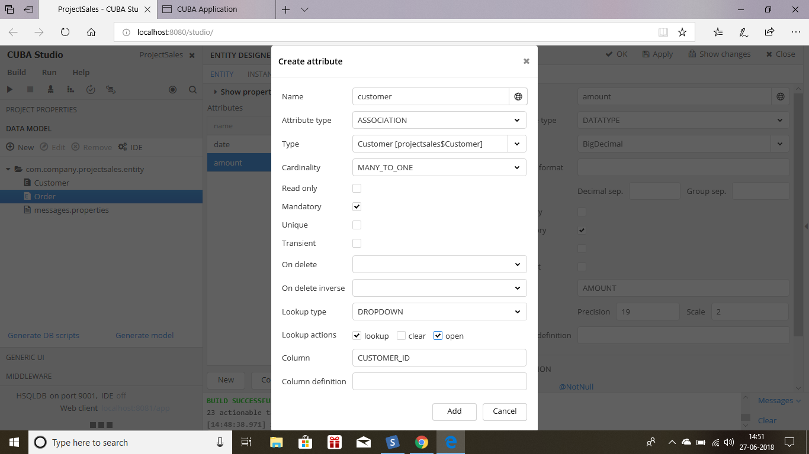*

* *Now generate Db scripts.*

*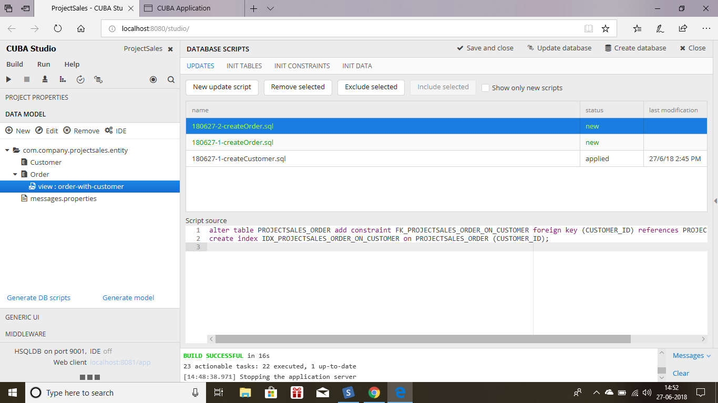*

* *Now create a view for this order and mention their Order view with customer.*

*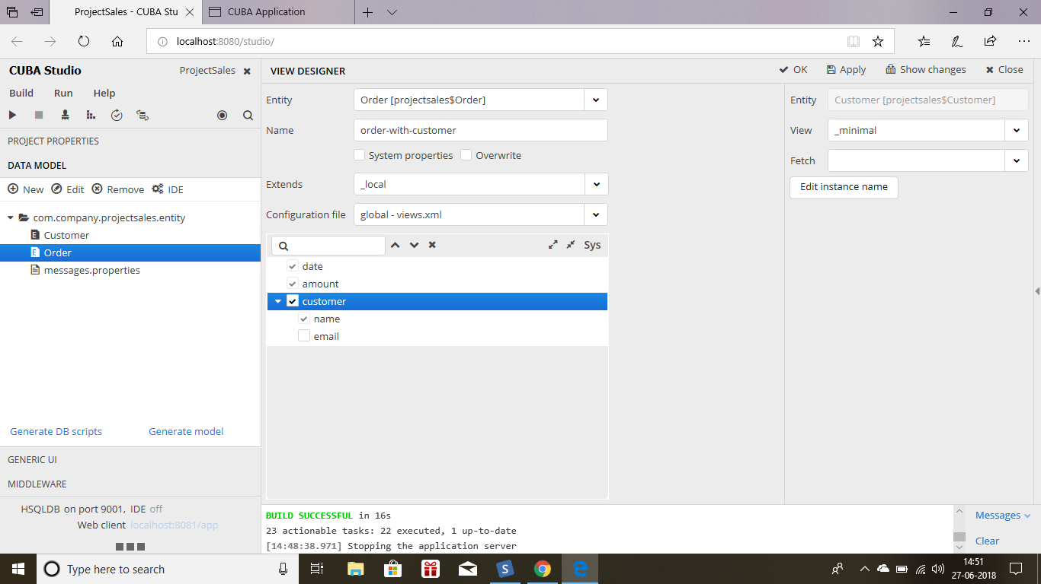*

* *Create generic UI screens for this order and give all the views as order edit with customer and generate screen.*

*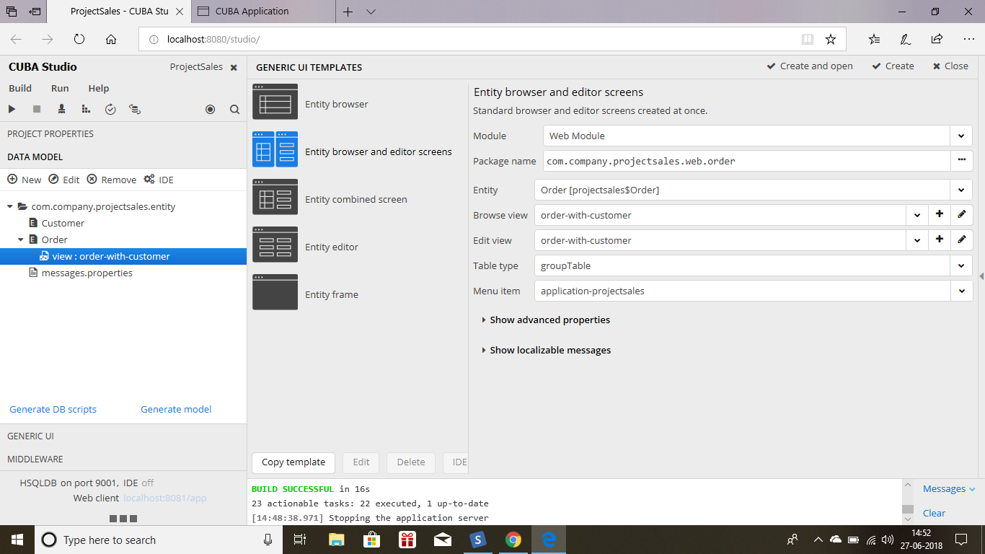*

*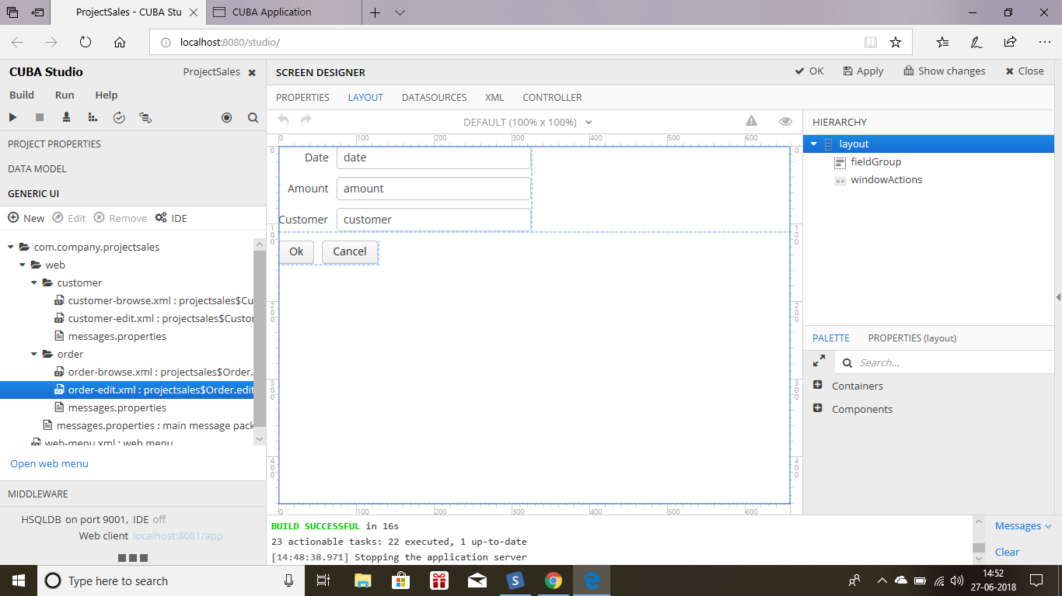*

* *Now click on customer edit go to layout and then add a label and give value to that label as orders and then create a table and give the table colomns names by using the properties for that table and use datasourse as orderDs.*
* *Create a new collection datasource and name it as OrderDs and write a query there.*

*select e from projectsales$Order e*

*where e.customer.id = :ds$customerDs*

*order by e.date*

*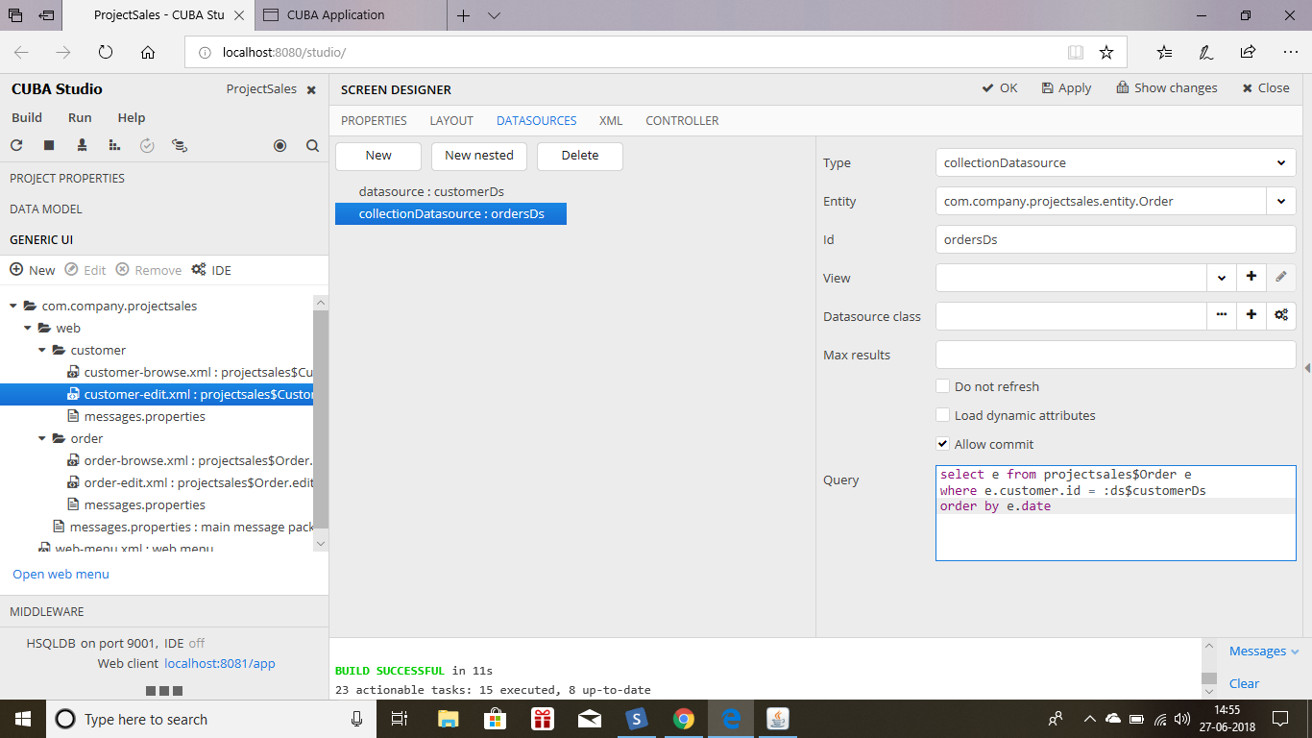*

*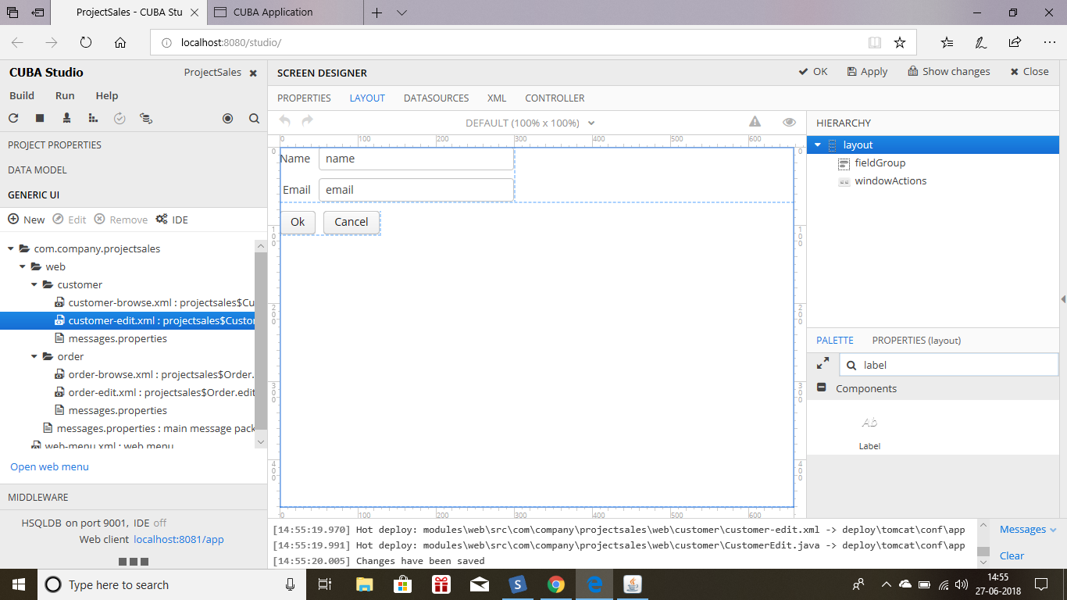*

*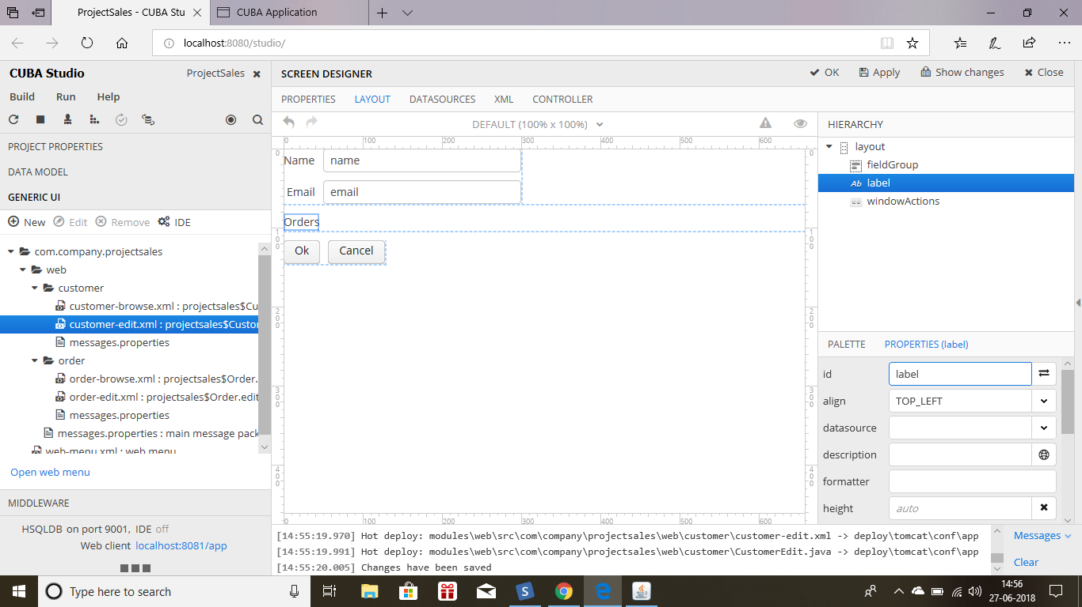*

*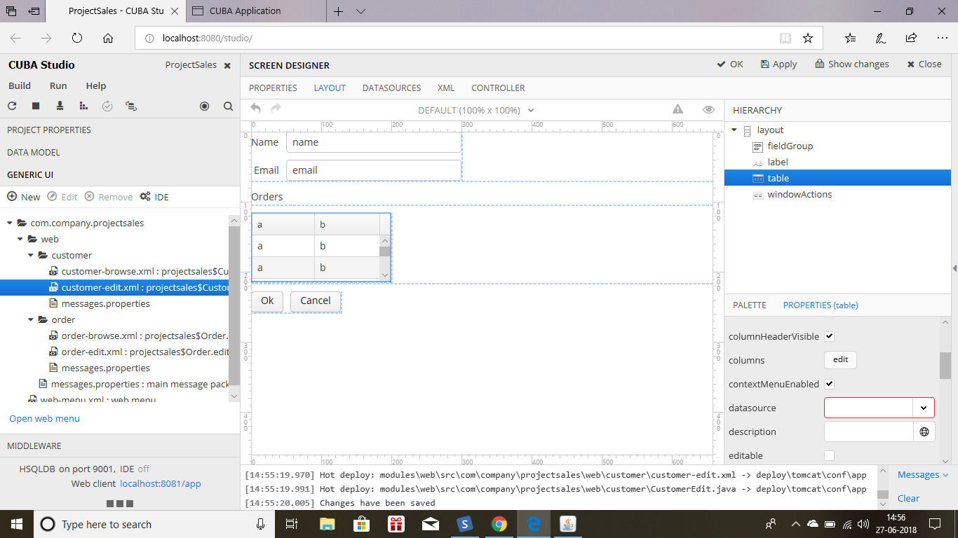*

*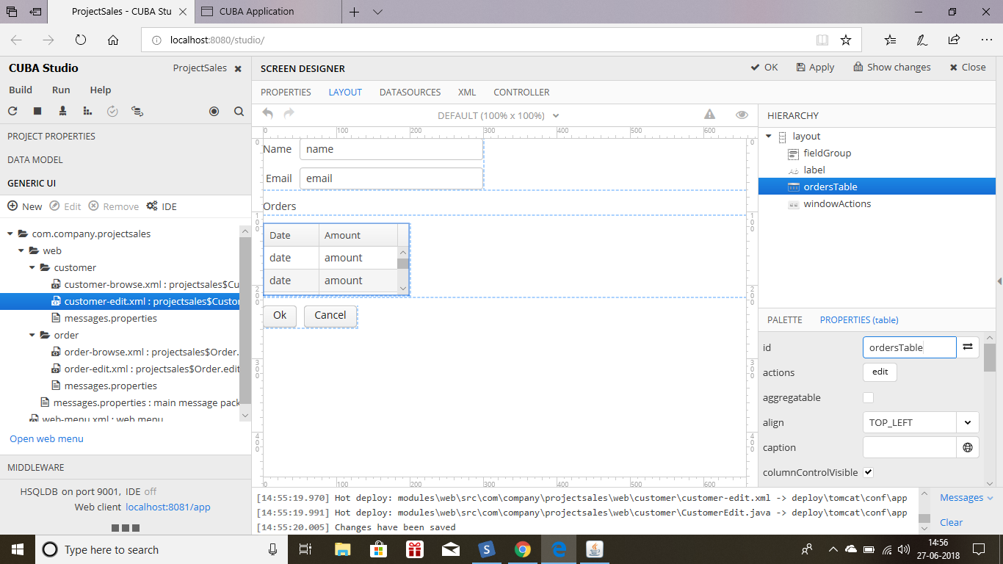*

*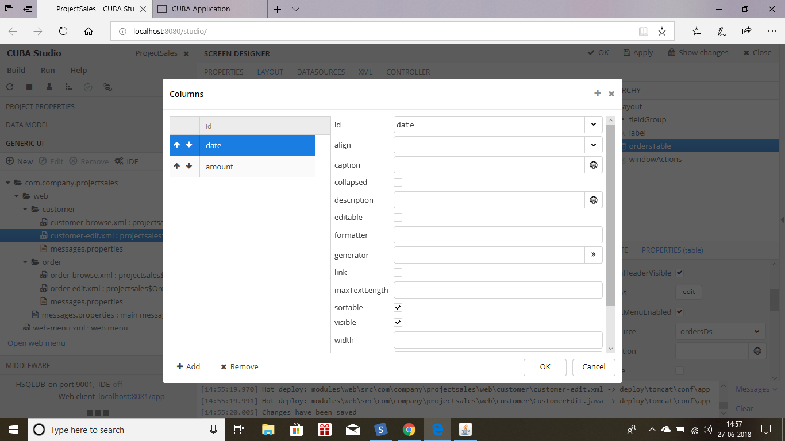*

*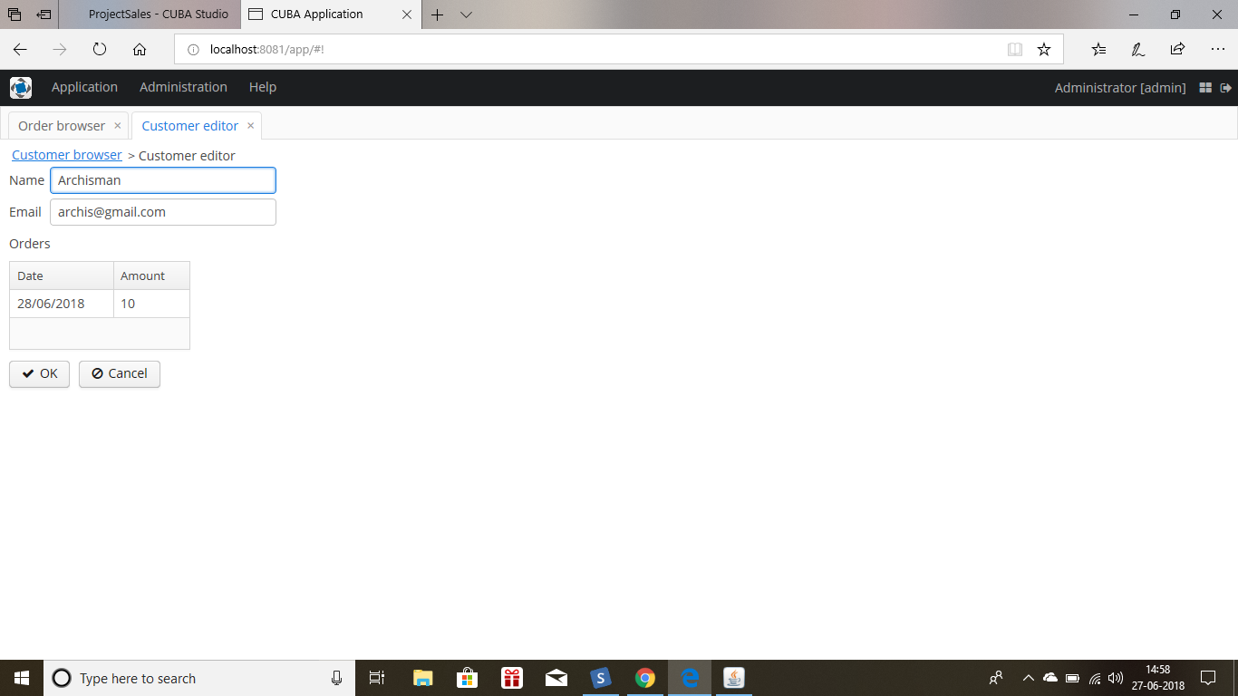*

*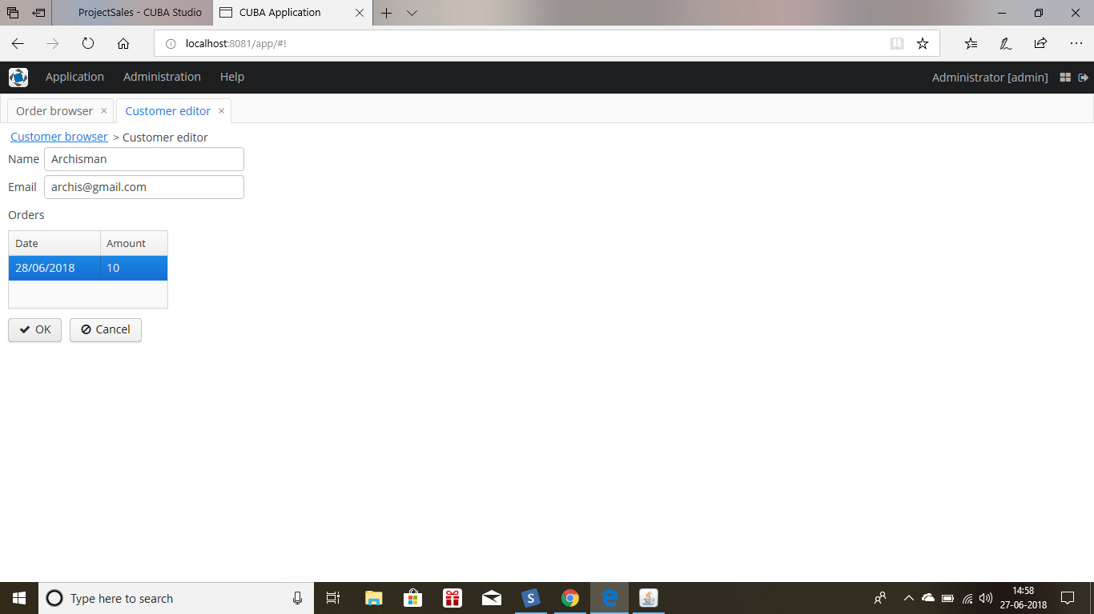*

* *Now create two models product and order lines to view the product price and quantity and name in the order edit screen.*

*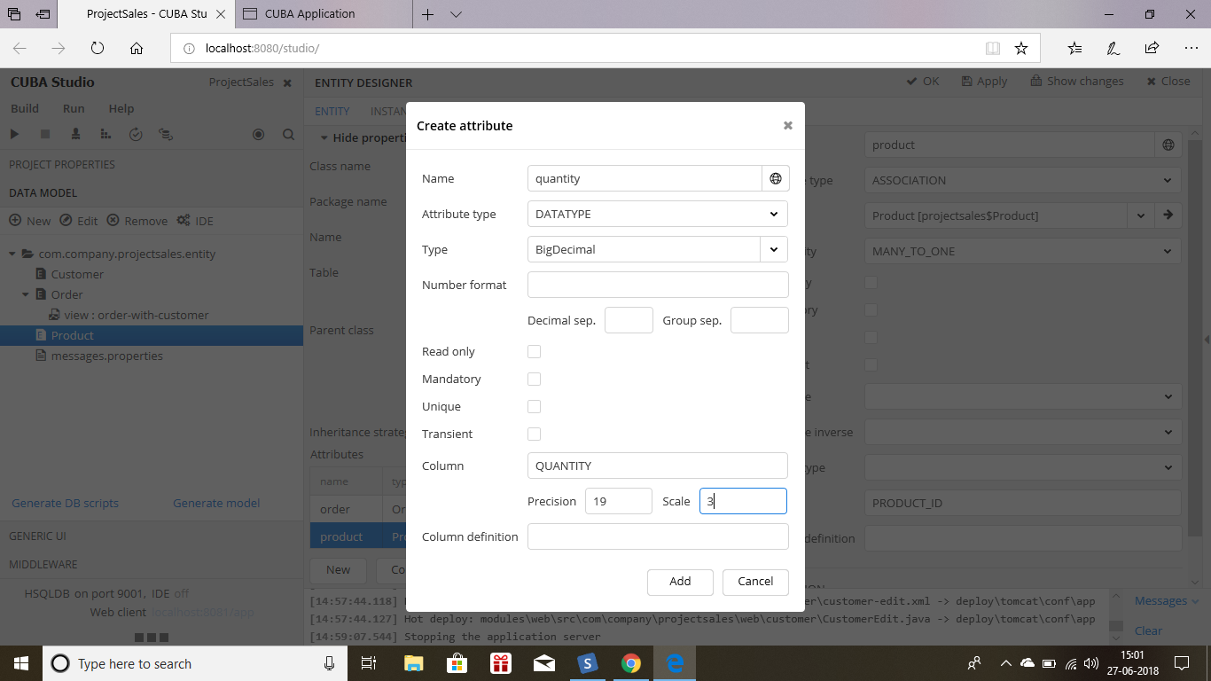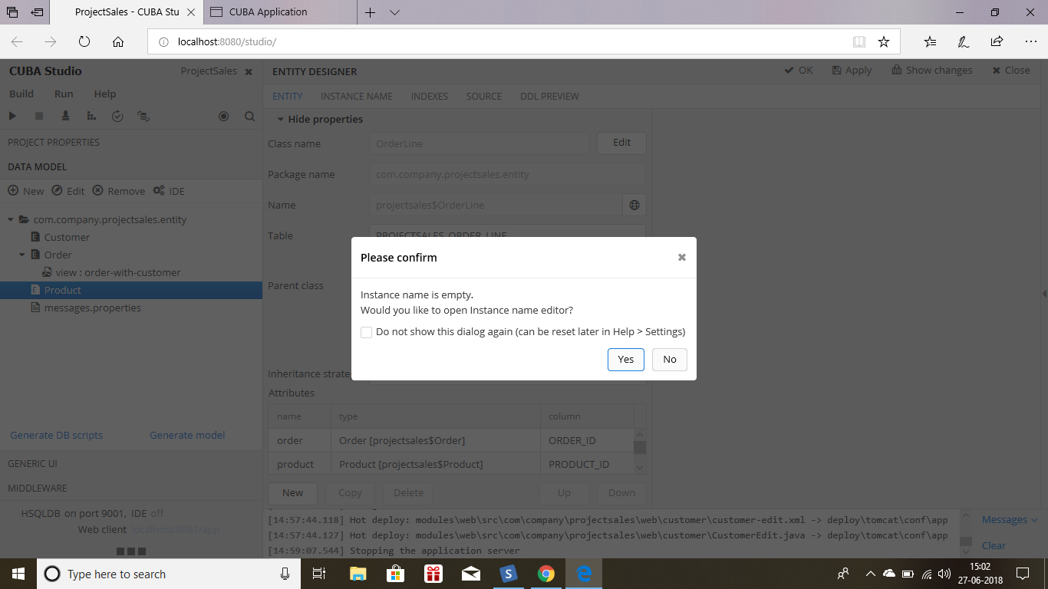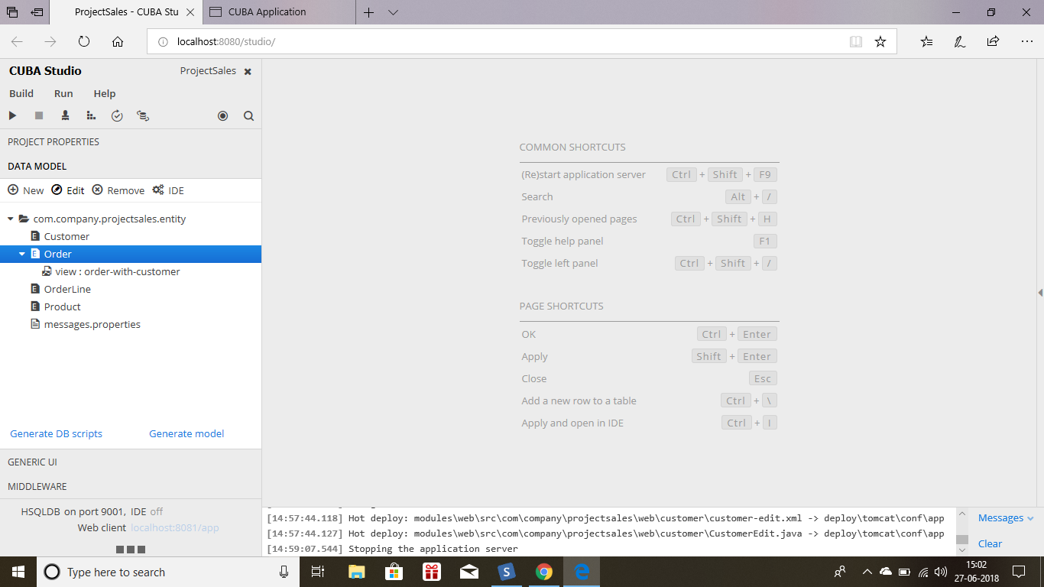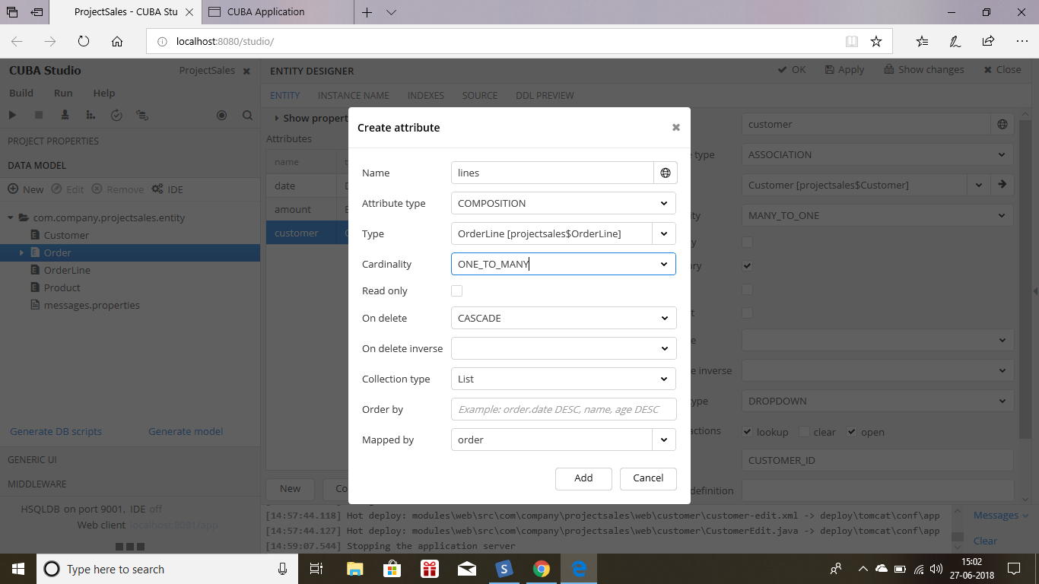*

* *In the product create two attributes as name and price both fields should be mandatory.*
* *And in the order lines create attributes like quantity and then create association to product and then create association to order. Both the carianality will be many to one.*
* *Now got to order and create a lines attribute to view the order lines in order edit screen.*
* *Create db scripts for this and update the database. 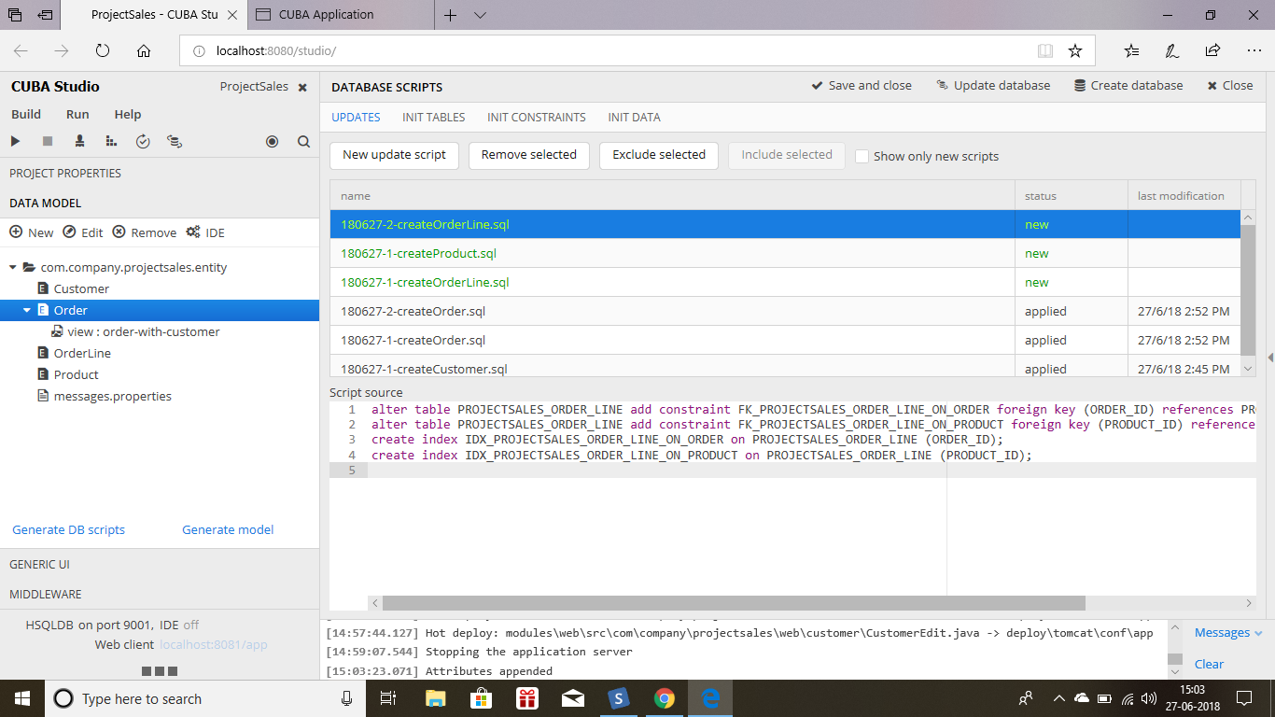*
* *Now create a view for this Order and give the name as order edit.and click on customer and lines . 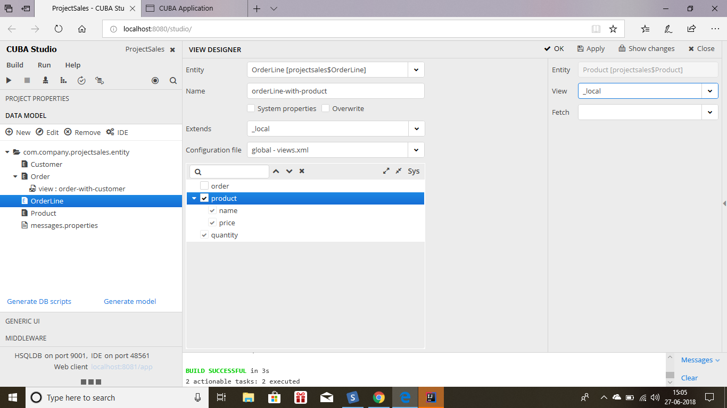*
* *Generate generic ui screen for this both product and create a entry editor for this orderliness.*

*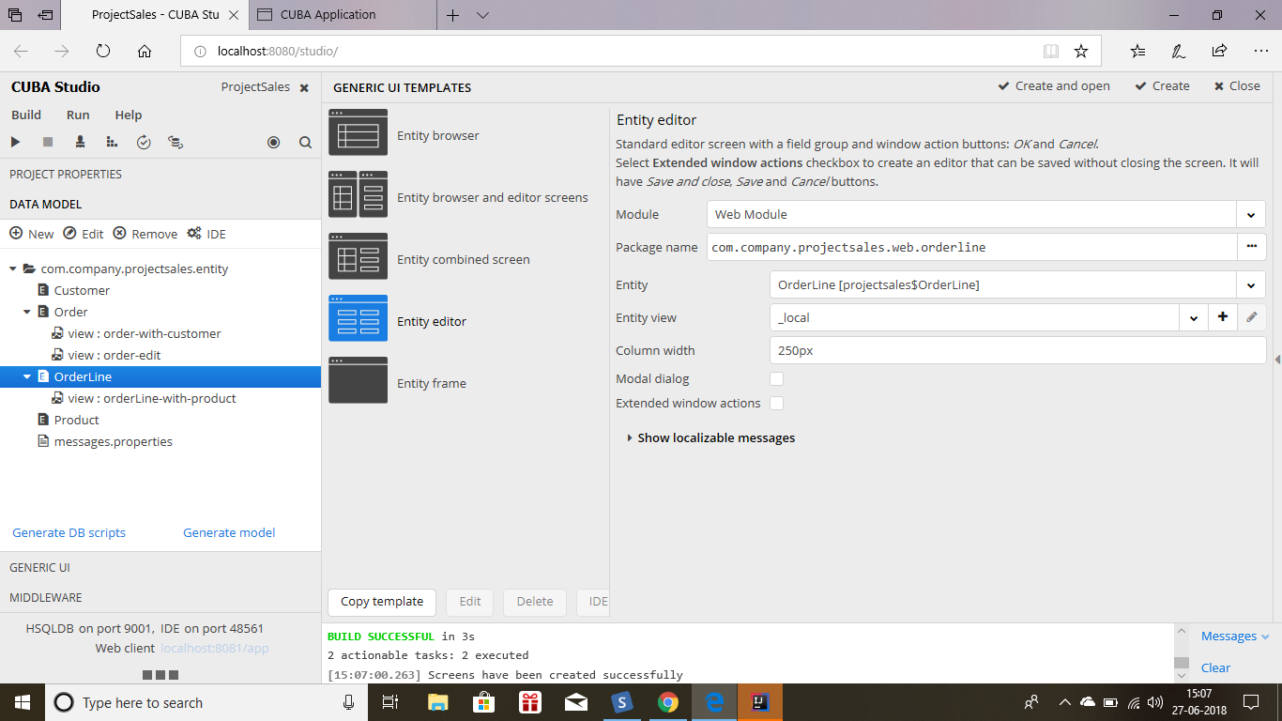*

*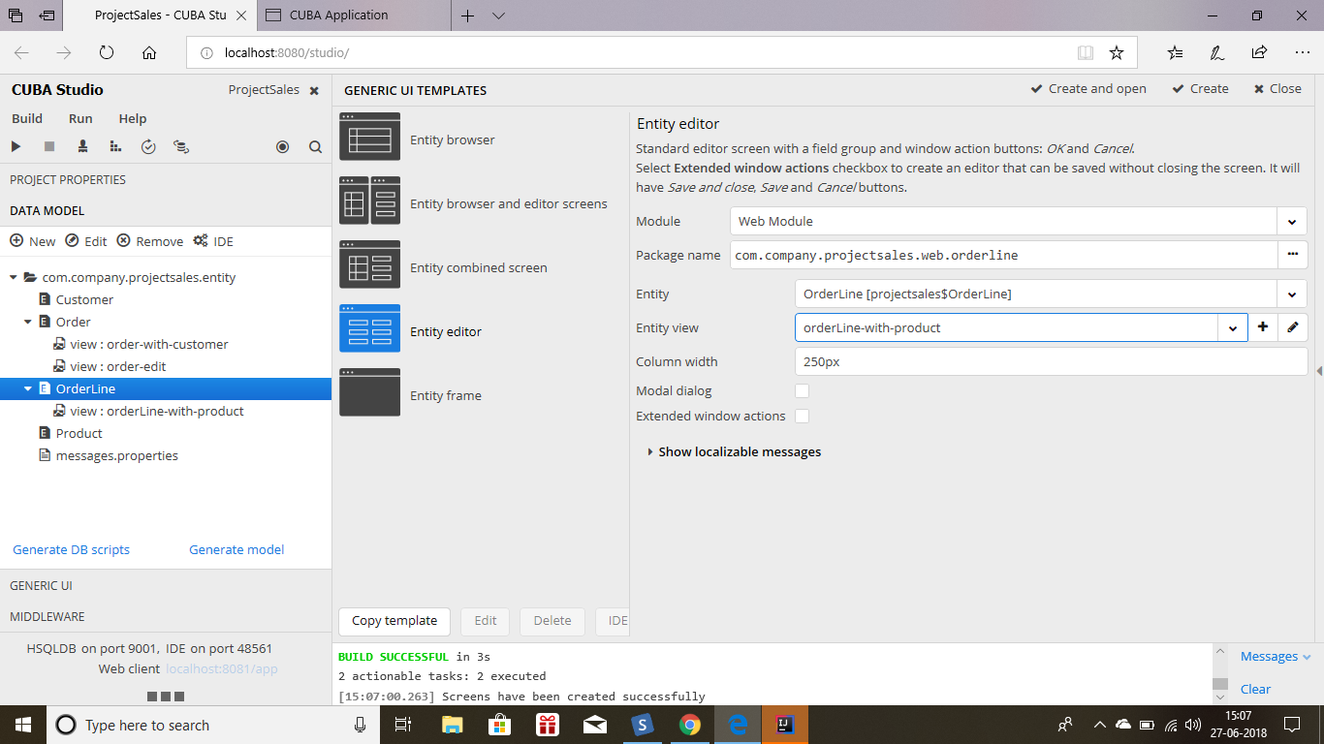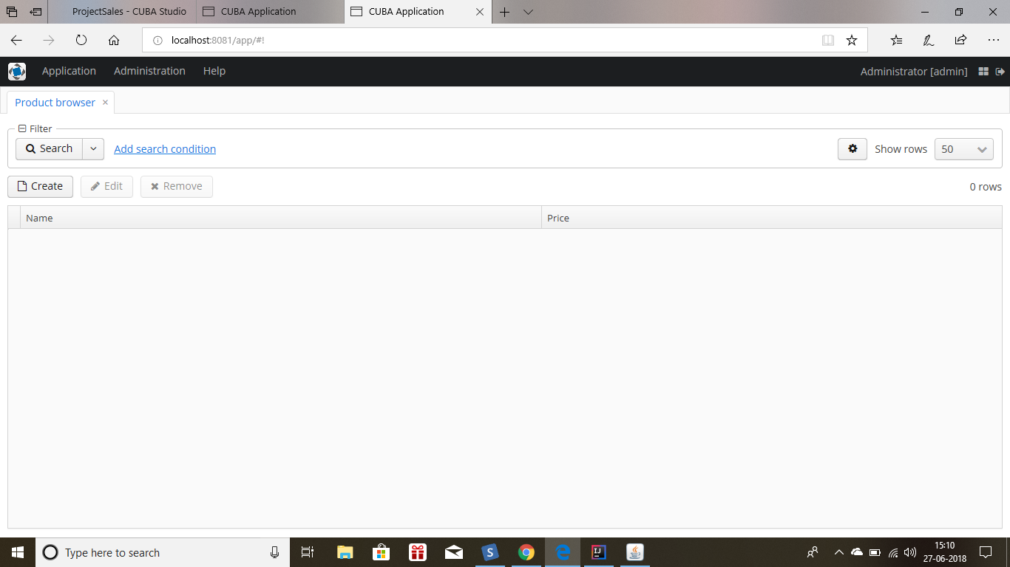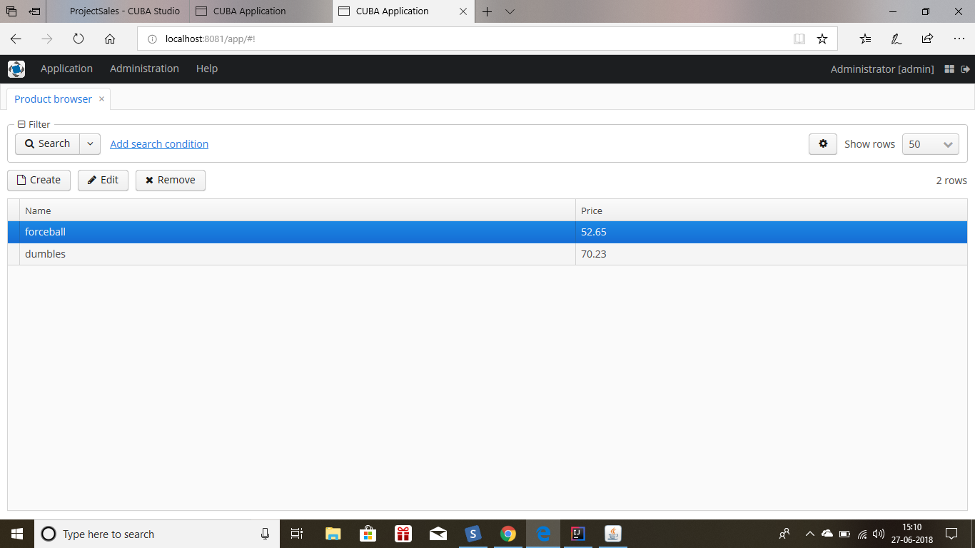*

* *Now above click will show this order edit browser will have this order lines which have only quantity. No we had to add the price and name before we want to get the total amount.*

*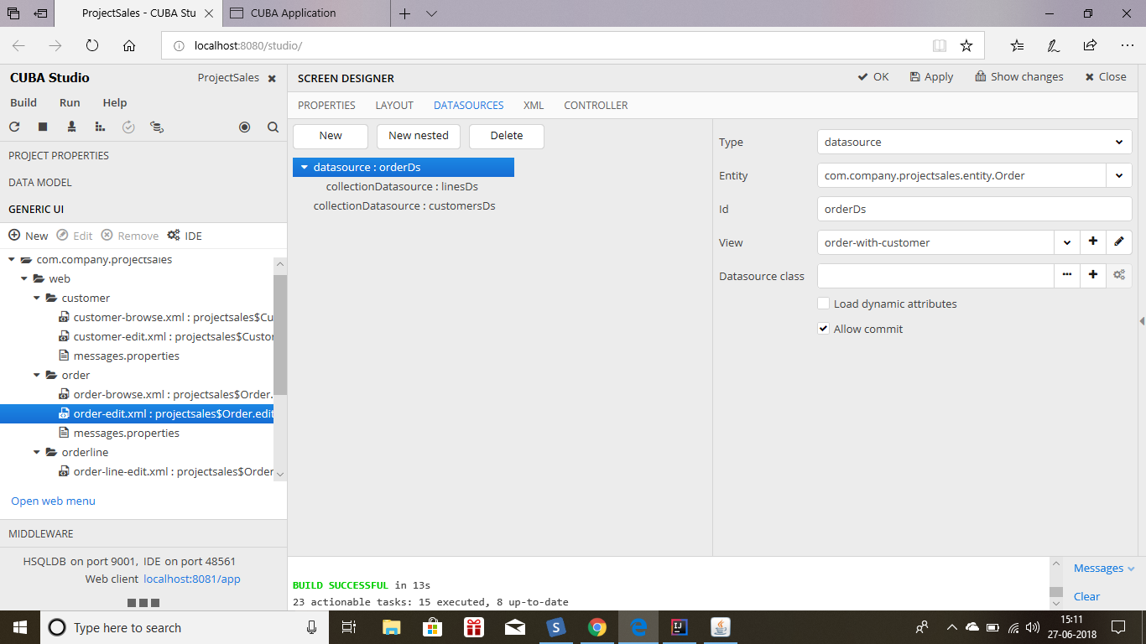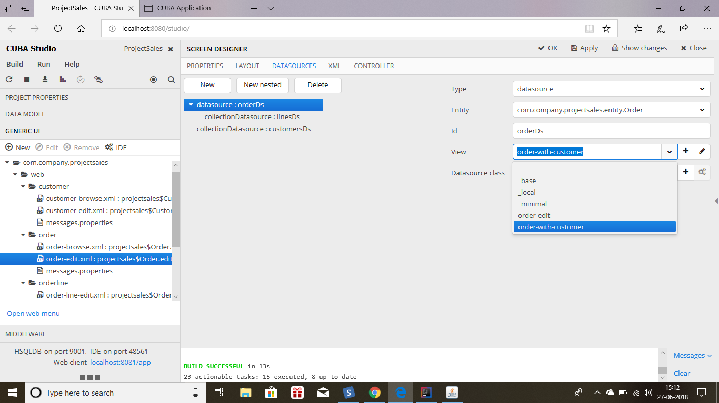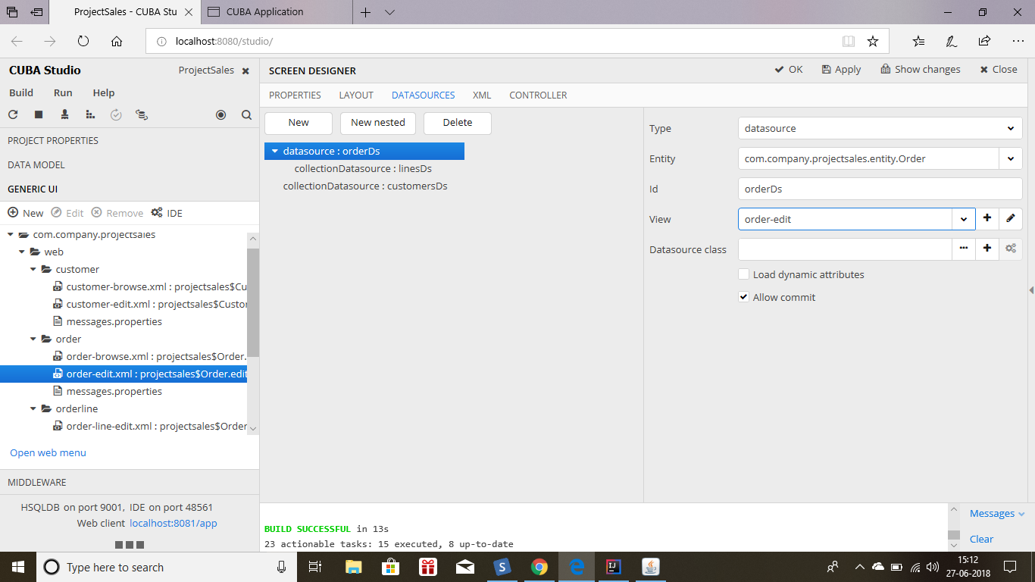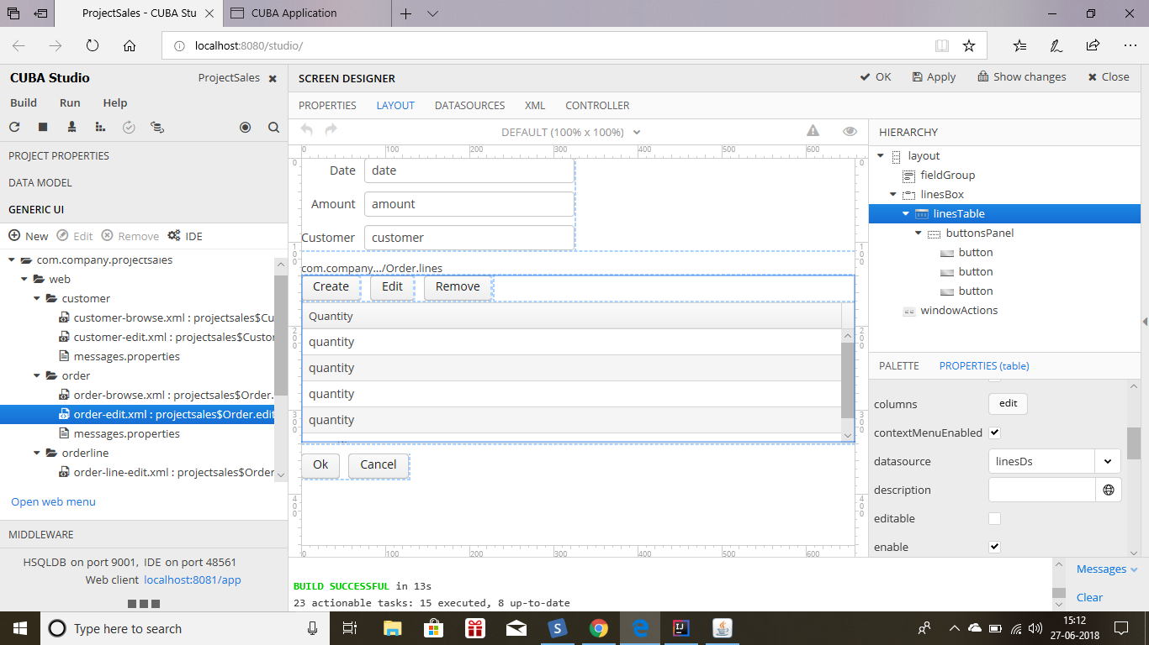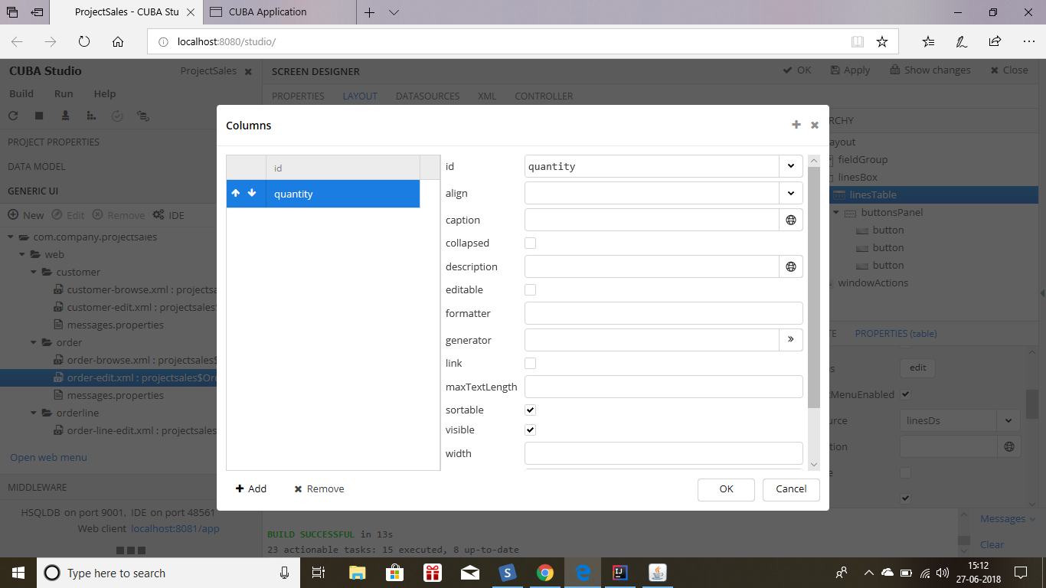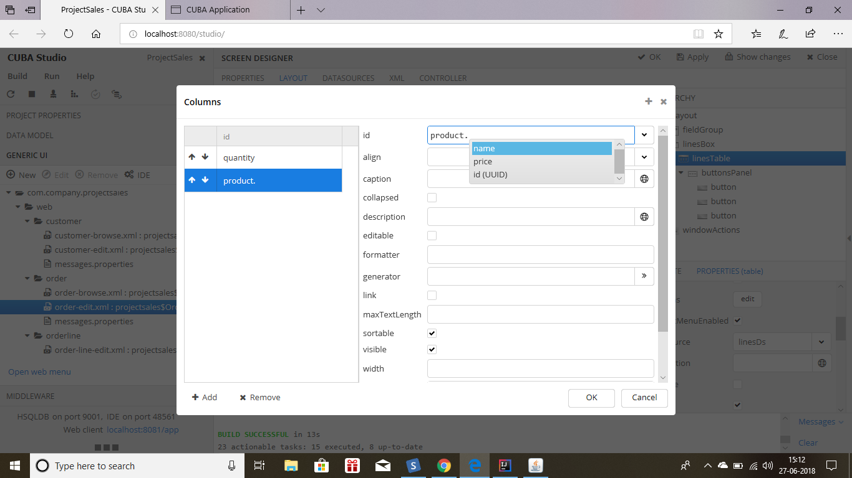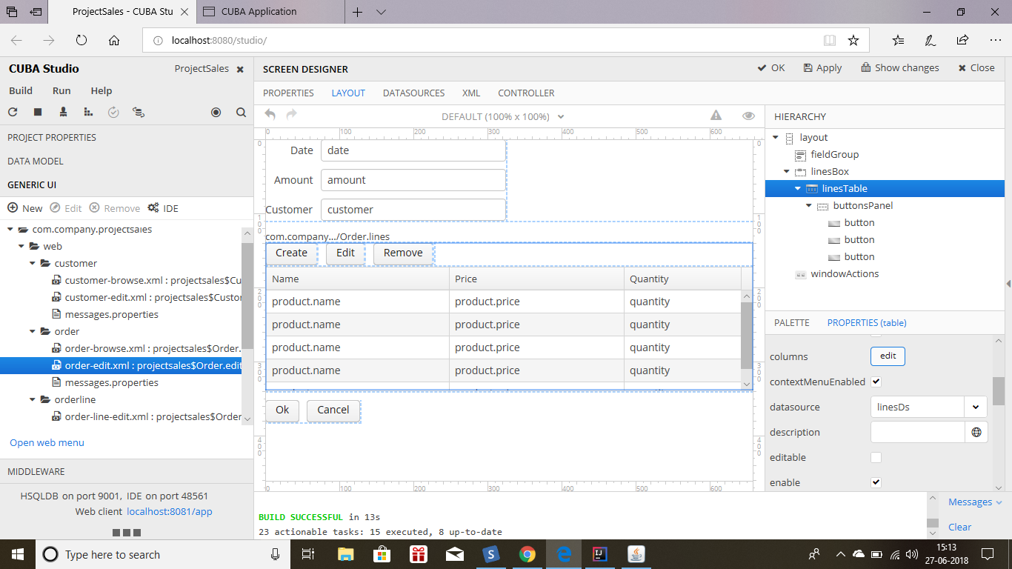*

* *Now open the order-edit.java to add the logic to calculate the total amount.*
* *Add inject by clicking right click then generate and then in the popup window click on lineDs.*
* *@Inject  
  private CollectionDatasource<OrderLine, UUID> linesDs;*
* *Add listener to the datasource in the nit method using lamda expression.*

*@Override  
protected void initNewItem(Order item) {  
 linesDs.addCollectionChangeListener(e -> calculateAmount());  
}*

* *The lamda expression will call the new calculate amount*
* *private void calculateAmount(){  
   BigDecimal amount = BigDecimal.ZERO;  
   for(OrderLine line : linesDs.getItems())  
   amount =amount.add(line.getProduct().getPrice().multiply(line.getQuantity()));  
   getItem().setAmount(amount);  
  }*

*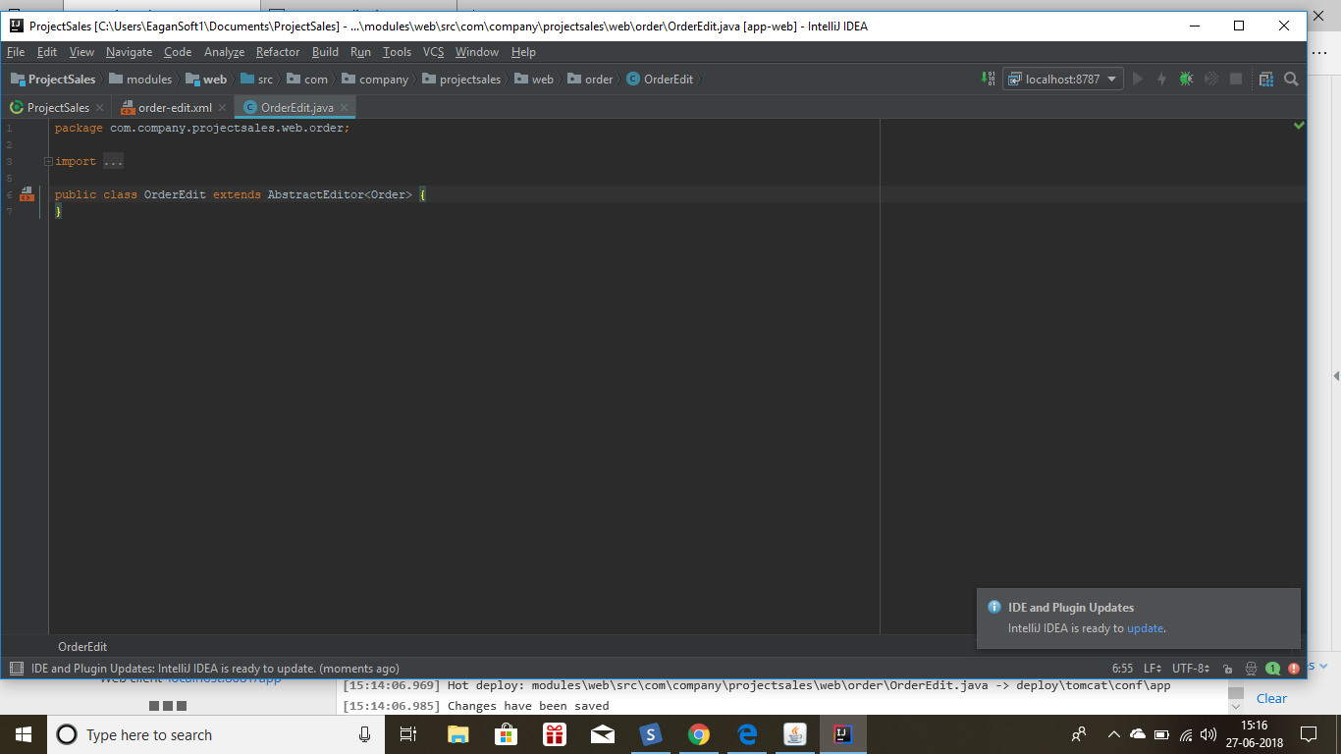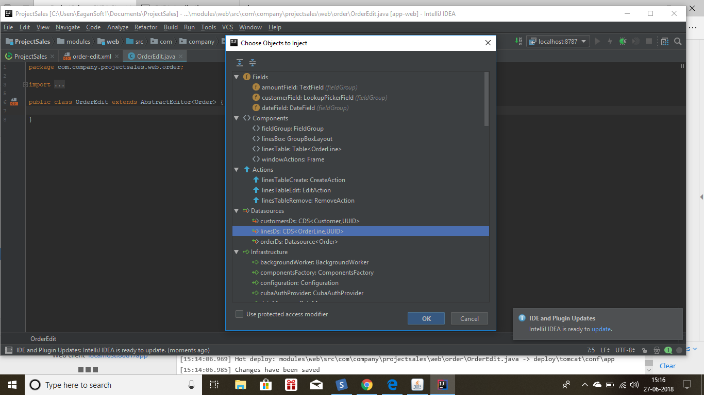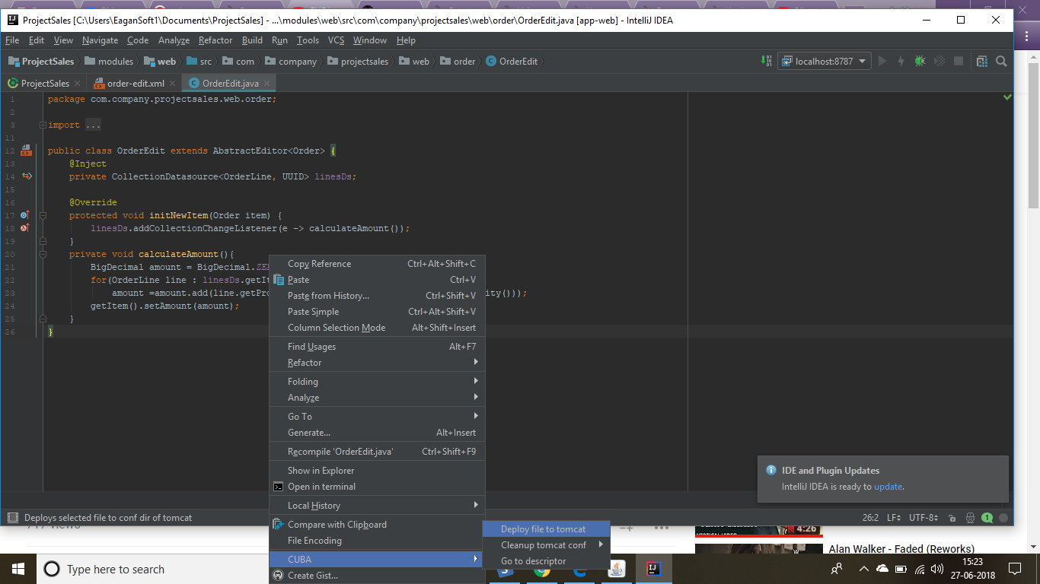*

*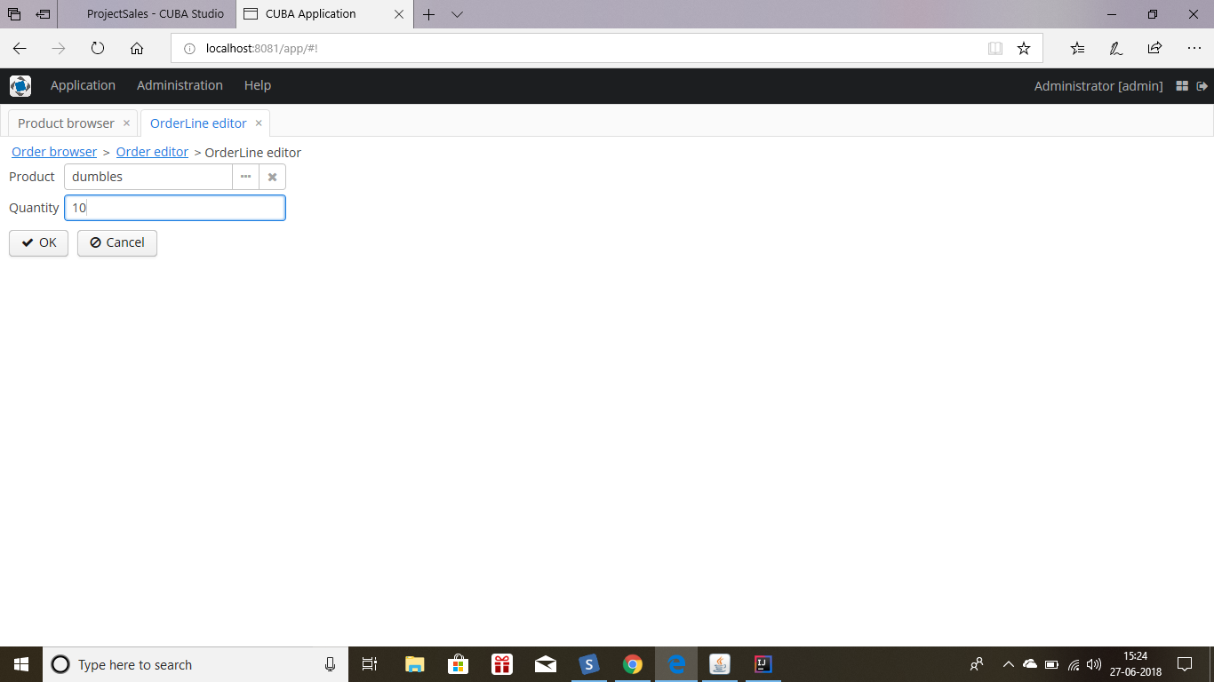*

*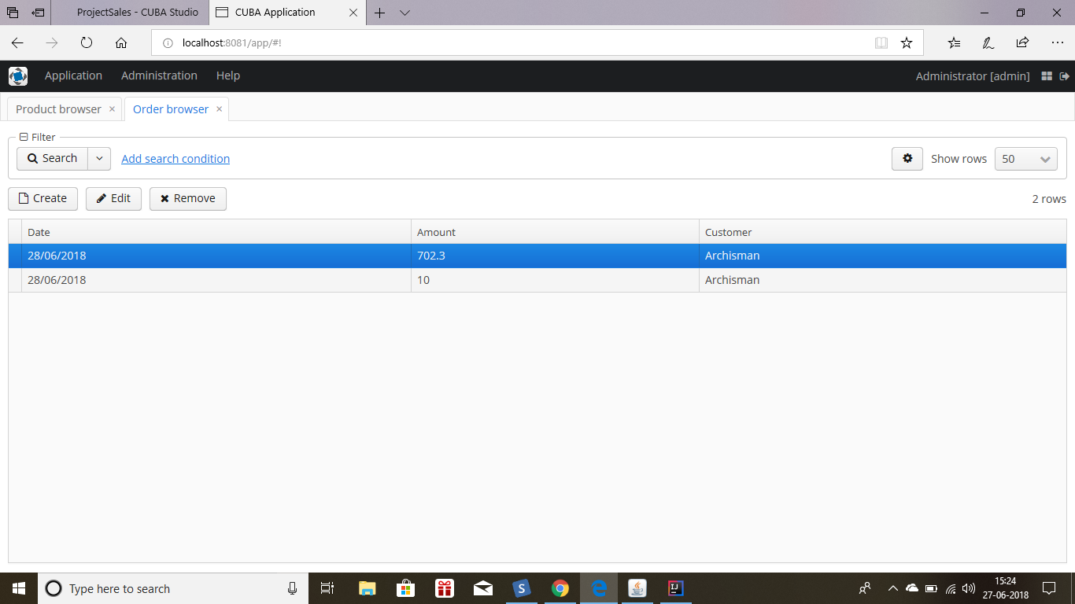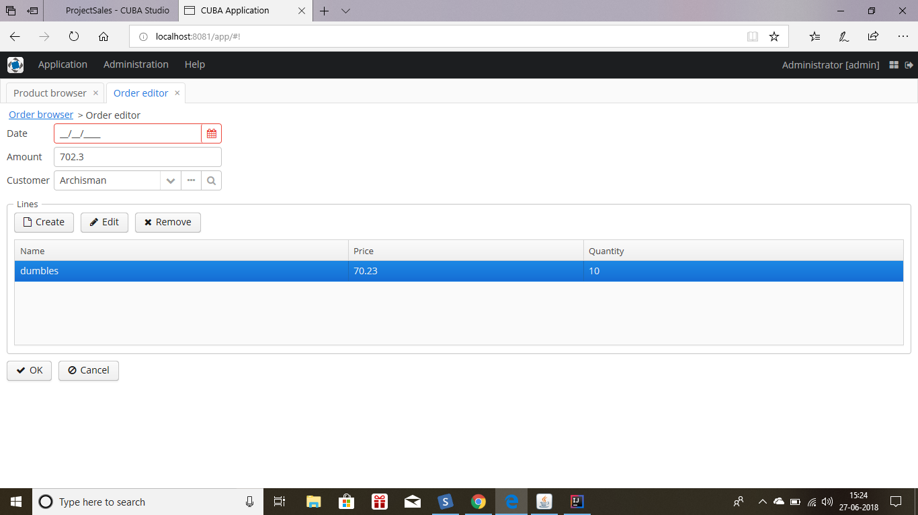*

*Now the total amount can be calculated by calling this listener whenever the user puts the quantity and price it will display the amount in the amount field of order edit.*

*====================================================================================================================================================================*

*